From Cowra Guardian, June 5 2014 - 3:30PM
https://www.cowraguardian.com.au/story/2332256/a-new-generation-of-friendship/
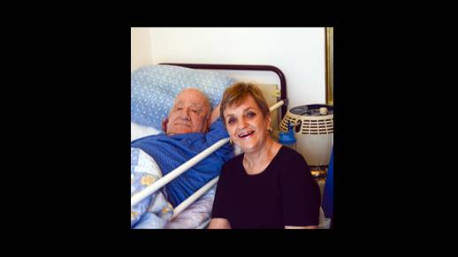

A new generation of friendship
The friendship forged by prisoners of war in Cowra during World War II continues to the next generation, with the daughter of a camp sergeant visiting a POW in Italy last month.
Carlo Vannucci was one of the well known 'Sacred Panel' Cowra POW camp artists, painting one of two panels which have recently been professionally preserved and stored at the Cowra Regional Art Gallery.
Sgt Bob Burge was in charge of the Engineering Section at the Cowra POW camp and worked with the Italian POWs.
He spoke of the rare skill of Vannucci in particular and a strong friendship grew.
The two maintained contact long after the war had ended, and now Sergeant Burge's daughter Colleen has been able to continue the friendship.
Through contact with the Cowra Italy Friendship Association, a meeting between Colleen and Carlo was arranged.
In May this year, Colleen went to Italy to visit Carlo Vannucci at his home in Viareggio.
Carlo, after repatriation in 1947, became the coordinator of the famous annual Carnevale di Viareggio, a position he maintained for fifty years.
A far cry from his work in Cowra during World War II, when he was forced to paint on canvas made from old flour bags.
His interest and artistic ability was noticed early on by Sgt Burge, who was able to organise paints and frames for the Italian POW to work on.
"Sometime later on a routine workshop inspection Vannucci took me by surprise with a gift of a framed painting which he had signed," Bob Burge said in 1975, in an article published in the local paper at the time.
"It was an impression from memory of a sea view in his home town Viareggio, an Italian well known seaside resort. There is a monument to the English poet, Shelley, in the town. He lived there at frequent times.
"The painting was an expression of Vannucci's thanks. When I gave it to my wife, Katie remarked on his artistic skill."

