Recommendation of the Executive Director and assessment of cultural heritage significance under Part 3, Division 3 of the Heritage Act 2017 | 

Name | Italian Ossario
Location | 21 Old Weir Road, Murchison, Greater Shepparton City
Provisional VHR Number | PROV H2405
Provisional VHR Categor(ies) | Registered Place
Hermes Number | TBA
Existing Heritage Overlay | HO64

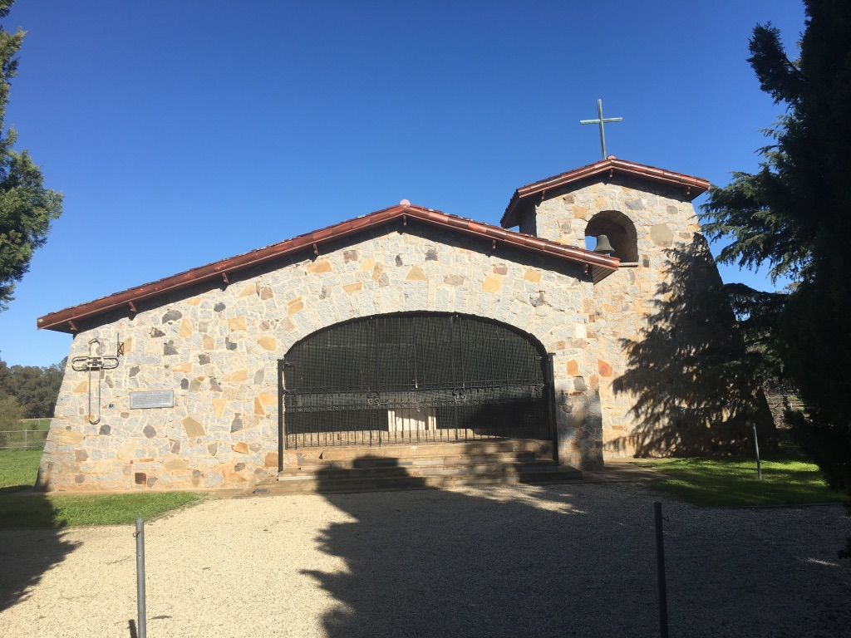

Italian Ossario, June 2020

EXECUTIVE DIRECTOR RECOMMENDATION TO THE HERITAGE COUNCIL:
- That the Italian Ossario be included as a Registered Place in the Victorian Heritage Register under the Heritage Act 2017 [Section 37(1)(a)].

STEVEN AVERY
Executive Director
Recommendation Date: Day Month Year
Advertising Period: Day Month Year

This recommendation report has been issued by the Executive Director, Heritage Victoria under s.37 of the Heritage Act 2017.

EXTENT OF NOMINATION
Date that the nomination was accepted by the Executive Director
23 June 2020

Written extent of nomination
All of the place shown hatched on Diagram 2405 encompassing part of Crown Allotment 7, Township of Murchison to the extent of part of the allotment boundaries to the northeast and south and 2 metres from the boundary fence along the west side between the grounds of the Ossario and the Murchison Cemetery.

Nomination extent diagram

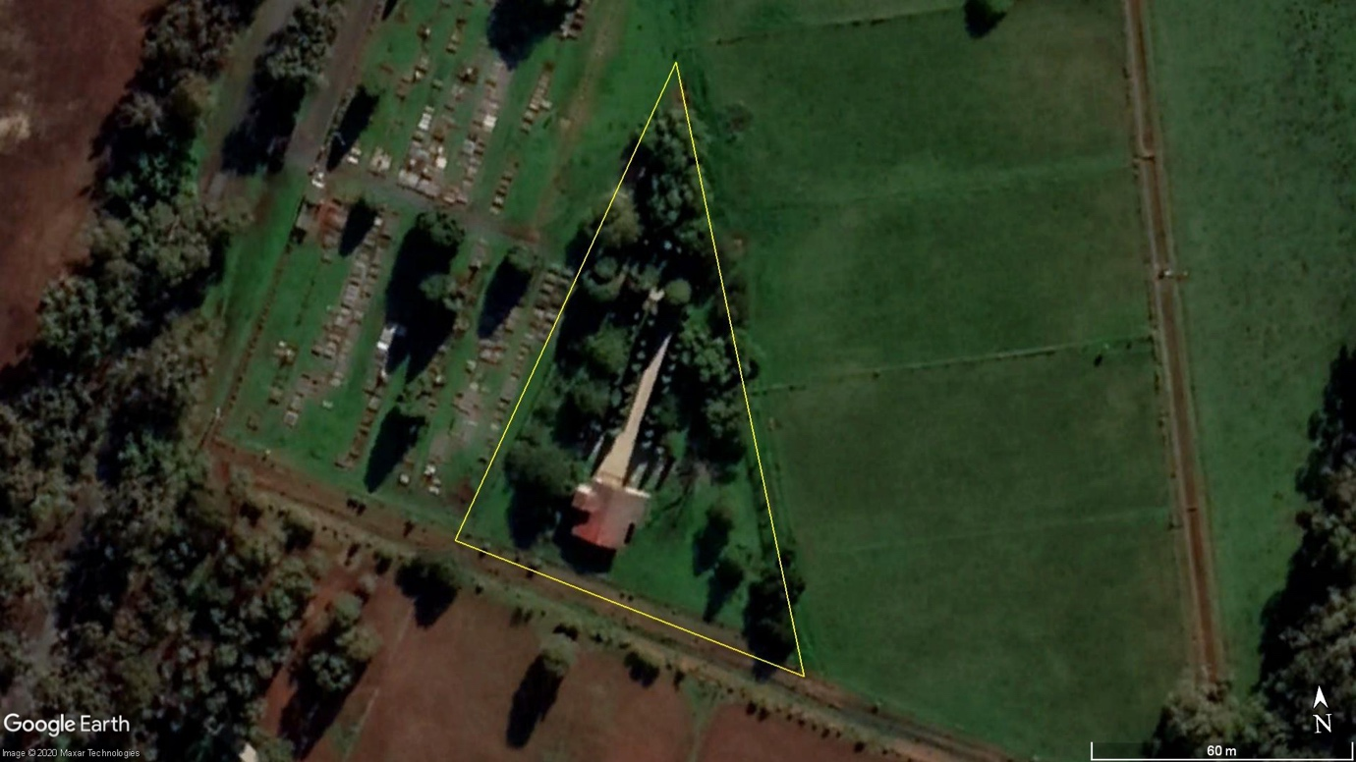

Is the extent of nomination the same as the recommended extent?
Yes.

RECOMMENDED REGISTRATION

All of the place shown hatched on Diagram 2405 encompassing part of Crown Allotment 7, Township of Murchison.

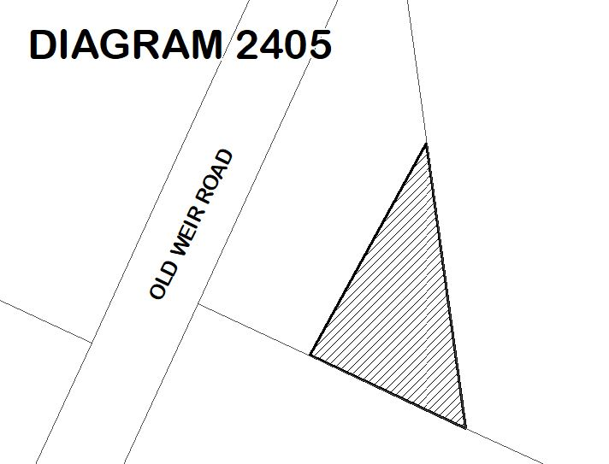

The recommended extent of registration of Italian Ossario in the Victorian Heritage Register affects the whole place shown on Diagram 2405 including the land, the Ossario (including the exteriors and interiors), two memorials, entry gates with bronze plaques, gravel path and forecourt, and Italian Cypress avenue and sign.

The registration also includes all fixtures attached to the building at the time of registration including light fittings, religious and memorial features, ornamental metal gates, marble altar, and plaques.

RATIONALE FOR EXTENT
The land containing the Italian Ossario is defined by fences on all sides and the proposed extent coincides with these boundary fences with the exception of the west side, where it has been extended two metres beyond to ensure that the stone entry gate posts have an appropriate curtilage.
.

EVIDENCE of cultural heritage values at the place

HOW ARE THE CULTURAL HERITAGE VALUES EXPRESSED AT THE PLACE?
The cultural heritage values are clearly expressed at the place, which remains highly intact, and includes the Ossario, associated memorials including one from the Rushworth POW camp, a memorial avenue of Italian Cypresses, and entry gates with bronze bas-relief plaques.

AERIAL PHOTO OF THE PLACE SHOWING PROPOSED REGISTRATION

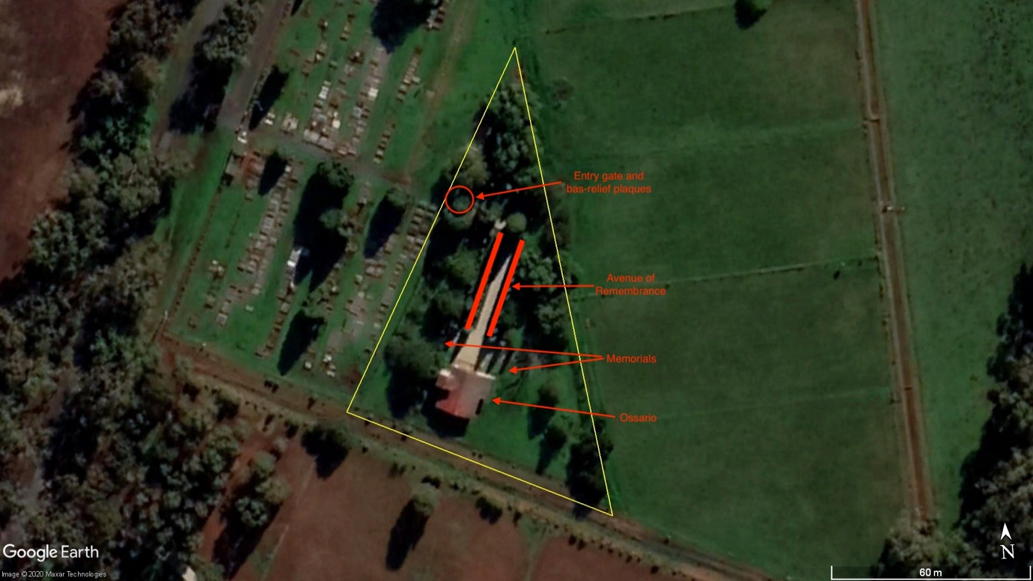

background

What is AT THE PLACE?
The Italian Ossario is located within a fenced triangular plot of land at the south-east corner of the Murchison Cemetery. The entrance is marked by two stone piers with bronze bas-relief panels of Saint Barbara and Saint Martin of Tours, flanked by smaller stone piers. These lead to the Viale delle Rimembranze (Avenue of Remembrance), which is identified with a metal sign and is lined with Italian Cypresses (Cupressus sempervirens), each with a plaque of an Italian service organisation, and frames the view toward the Ossario. The Ossario is a single storey stone building with attached bell tower, similar to rural vernacular Italian architecture. External walls are of rubble granite and are battered on either side. The roof is a shallow pitched gable clad in terracotta tiles with projecting eaves and a cross surmounting the bell tower roof. The front section contains a chapel with a wide arched opening now enclosed with wrought iron gates. On the façade to left of the opening is a plaque commemorating the 1966 reconstruction, and a memorial cross marking the association with the Italian military shrine at El Alamein. Within the chapel is a white marble altar below a copper lantern that hangs from the vaulted timber ceiling, which has expressed beams and timber lining. On the wall behind is a simple timber cross, which is flanked by arched timber doors leading to the mausoleum, and other crosses and plaques. Large bronze panels on the end walls list the names of the internees and there is another pair of timber doors at the north end. Behind the chapel is the mausoleum, which has a terrazzo floor and a timber ceiling with brass downlights. The coffins are contained in metal compartments with polished wood facings, each with a lacquered hardwood plaque with the name of the deceased, that are stacked five coffins high in rows of ten. The Ossario faces a gravel courtyard flanked by two memorials. On the east side is the 1968 Italian POW memorial, while on the west side is the 1975 memorial.

WhaT IS THE HISTORY OF THE PLACE?
The Italian Ossario, Murchison is one of four foreign war cemeteries established in Australia after World War II and the only one that was not created by the Australian War Graves Commission. An initiative of the Italian Consulate working with an Italian returned servicemen’s organization and a local man, Luigi Gigliotti, it was established on land forming part of the Murchison Cemetery and provided for the reburial of 130 Italian internees and Prisoners of War who died while detained in Australia during World War II. Bodies already at Murchison Cemetery and from cemeteries throughout Australia were exhumed and reinterred within the Ossario, which is located in close proximity to the largest group of World War II internment camps constructed in Australia. These consisted of seven camps which housed more than 8,000 civilians and Prisoners of War largely from Germany, Italy and Japan. The first section of the Ossario comprising the chapel, bell tower and underground crypt, and the entry gates, was opened in September 1961 by by the Hon. Ferninando Storchi, the Under Secretary for Foreign Affairs and Minister for Migration in Italy, at a ceremony attended by some 1000 people. The design has been attributed to Italian architect and builder Paolo Caccia Dominioni and was realized and documented by Victorian architect, Charles Hollinshed. The ossario was rebuilt in 1966 and extended in 1974 when the remains were moved to a mausoleum at the rear, and bas relief panels were added to the entry gates. A memorial from the internment camp at Rushworth was relocated here in 1968, and another memorial added in 1975. A memorial avenue of Italian Cypresses dedicated to Italian service organisations was established in 1989.

WhO ARE THE TRADITIONAL OWNERs/REGISTERED ABORIGINAL PARTY(IES) FOR THIS PLACE?
This place is located on the traditional land of the Yorta Yorta people. The Registered Aboriginal Party for this land is the Yorta Yorta Nation Aboriginal Corporation.

STATEMENT OF CULTURAL HERITAGE SIGNIFICANCE

What is significant? (What are the significant elements?)
This Italian Ossario (including the exteriors and interiors), two memorials, entry gates with bronze bas relief plaques, gravel path and forecourt, and Italian Cypress avenue and sign.

How is it significant? (Which criteria apply?)
The Italian Ossario is of historic and social significance to the State of Victoria. It satisfies the following criterion for inclusion in the Victorian Heritage Register:

Criterion A
Importance to the course, or pattern, of Victoria’s cultural history.

Criterion B
Possession of uncommon, rare or endangered aspects of Victoria’s cultural history.

Criterion G
Strong or special association with a particular present-day community or cultural group for social, cultural or spiritual reasons.

Why is it significant?
The Italian Ossario is significant at the State level for the following reasons:

The Italian Ossario is historically significant as one of two foreign war cemeteries established in Victoria after the end of World War II. Developed in stages from 1958 to 1974, it remains highly intact and demonstrates the relationship that developed between former enemy nations soon after the end of World War II. The choice of a mausoleum in a traditional Italian architectural style to house the remains, and the associated formal Italian Cypress avenue clearly demonstrates the historic association with Italy. [Criterion A]

The Italian Ossario is the only war cemetery in Australia dedicated to Italian civilians and Prisoners of War. It is one of only four foreign war cemeteries in Australia and the only one that was not established by the Office of Australian War Graves. The POW memorial is one of the few remaining structures associated with the nearby internment camps. [Criterion B]

The Italian Ossario is socially significant for its longstanding relationship with the Italian community in Victoria. Since 1961 it has provided this community with a place for remembrance with official commemoration services held annually in November, continuing a tradition first established at Murchison Cemetery in 1956. [Criterion G]

RECOMMENDATION REASONS

REASONS FOR RECOMMENDING INCLUSION IN THE VICTORIAN HERITAGE REGISTER [s.40]
Following is the Executive Director's assessment of the place against the tests set out in The Victorian Heritage Register Criteria and Thresholds Guidelines (2014).

CRITERION A
Importance to the course, or pattern, of Victoria’s cultural history.

STEP 1: A TEST FOR SATISFYING CRITERION A
The place/object has a clear ASSOCIATION with an event, phase, period, process, function, movement, custom or way of life in Victoria’s cultural history.
Plus
The association of the place/object to the event, phase, etc IS EVIDENT in the physical fabric of the place/object and/or in documentary resources or oral history.
Plus
The EVENT, PHASE, etc is of HISTORICAL IMPORTANCE, having made a strong or influential contribution to Victoria.

Executive Director’s Response
The Italian Ossario has a clear association with Australia’s involvement in World War II as one of four foreign war cemeteries established in Australia. It provides a clear and important illustration of the relationship that developed between former enemy nations soon after the end of World War II. It contains the remains of both Italian civilians and Prisoners of War, many of whom had been interned at nearby camps for the duration of World War II, and others interned throughout Australia. The choice of a mausoleum in a traditional Italian architectural style to house the remains, and the associated formal Italian Cypress avenue clearly demonstrates the historic association with Italy. The importance of the memorial to the Italian Government is also demonstrated in documentary sources, where it is referred to as a ‘National Shrine’ and is compared to the Italian Military Shrine at El Alamein, which was designed by the same architect.
The Italian Ossario has strong associations with the history of internment camps in Victoria. The Ossario is close to the largest group of World War II internment camps in Australia, and many of the people whose remains are now kept here had previously been interned nearby. The memorial from Camp 3 at Rushworth, relocated to this site in 1968, also demonstrates this connection.
Criterion A is likely to be satisfied.

STEP 2: STATE LEVEL SIGNIFICANCE TEST FOR CRITERION A
The place/object allows the clear association with the event, phase etc. of historical importance to be UNDERSTOOD BETTER THAN MOST OTHER PLACES OR OBJECTS IN VICTORIA WITH SUBSTANTIALLY THE SAME ASSOCIATION.

Executive Director’s Response
The Italian Ossario is highly intact and clearly illustrates the internment of Italians in Victoria during World War II. There are no other comparable places with substantially the same association, although the German War Cemetery at Tatura is equivalent in relation to the internment of German citizens. The association with World War II is also illustrated to an extent by some physical evidence which remains at nearby World War II internment camps, and through an array of camp-related items held at the Irrigation and Wartime Camps Museum, Tatura.

Criterion A is likely to be satisfied at the State level.

CRITERION B
Possession of uncommon, rare or endangered aspects of Victoria’s cultural history.

STEP 1: A TEST FOR SATISFYING CRITERION B
The place/object has a clear ASSOCIATION with an event, phase, period, process, function, movement, custom or way of life of importance in Victoria’s cultural history.
Plus
The association of the place/object to the event, phase, etc IS EVIDENT in the physical fabric of the place/object and/or in documentary resources or oral history.
Plus
The place/object is RARE OR UNCOMMON, being one of a small number of places/objects remaining that demonstrates the important event, phase etc.
OR
The place/object is RARE OR UNCOMMON, containing unusual features of note that were not widely replicated
OR
The existence of the class of place/object that demonstrates the important event, phase etc is ENDANGERED to the point of rarity due to threats and pressures on such places/objects.

Executive Director’s Response
The Italian Ossario is the only Italian War Cemetery in Australia and is one of two foreign war cemeteries in Victoria and only four in Australia. The others are the German War Cemetery established nearby at Tatura, a Japanese War Cemetery was established at Cowra, New South Wales, and there is a Dutch Annexe at the Perth Cemetery, Western Australia.
The POW memorial from Camp 3 at Rushworth is also rare, as one of the few surviving structures associated with the internment camps.
Criterion B is likely to be satisfied.

STEP 2: STATE LEVEL SIGNIFICANCE TEST FOR CRITERION B
The place/object is RARE, UNCOMMON OR ENDANGERED within Victoria.

Executive Director’s Response
The Italian Ossario is the only Italian War cemetery in Australia and is one of only two foreign war cemeteries in the state.
Criterion B is likely to be satisfied at the State level.

CRITERION C
Potential to yield information that will contribute to an understanding of Victoria’s cultural history.

STEP 1: A TEST FOR SATISFYING CRITERION C
The:
- visible physical fabric; &/or
- documentary evidence; &/or
- oral history,
relating to the place/object indicates a likelihood that the place/object contains PHYSICAL EVIDENCE of historical interest that is NOT CURRENTLY VISIBLE OR UNDERSTOOD.
Plus
From what we know of the place/object, the physical evidence is likely to be of an INTEGRITY and/or CONDITION that it COULD YIELD INFORMATION through detailed investigation.

Executive Director’s Response
The Italian Ossario is unlikely to contain physical evidence of historical interest (such as archaeological evidence) that is not currently visible or understood. While the crypt remains under the chapel, all of the significant fabric associated with this (the containers holding the coffins and associated features) was relocated to the Mausoleum and it was infilled with sand. Detailed architects’ drawings showing the crypt are held in the Public Records Office of Victoria archives.

Criterion C is not likely to be satisfied.

CRITERION D
Importance in demonstrating the principal characteristics of a class of cultural places and objects.

STEP 1: A TEST FOR SATISFYING CRITERION D
The place/object is one of a CLASS of places/objects that has a clear ASSOCIATION with an event, phase, period, process, function, movement, important person(s), custom or way of life in Victoria’s history.
Plus
The EVENT, PHASE, etc is of HISTORICAL IMPORTANCE, having made a strong or influential contribution to Victoria.
Plus
The principal characteristics of the class are EVIDENT in the physical fabric of the place/object.

Executive Director’s Response
The Italian Ossario is in the class of war cemetery and is and has a clear association with the internment of Italian civilians and POWs during World War II, and the relationship that developed between former enemy nations soon after the end of World War II. This is better addressed under Criteria B (Rarity) because of the lack of comparative examples.

The Italian Ossario is also in the class of Mausolea, as a distinctive form of burial practice. However, the construction of the mausoleum, while an early example, appears to have been an exception to a rule and does not appear to have made a strong or influential contribution to the development of mausolea in Victoria, which were not made legal until 1994.

Criterion D is not likely to be satisfied.

Criterion E
Importance in exhibiting particular aesthetic characteristics.

STEP 1: A TEST FOR SATISFYING CRITERION E
The PHYSICAL FABRIC of the place/object clearly exhibits particular aesthetic characteristics.

Executive Director’s Response
The Italian Ossario clearly exhibits particular aesthetic characteristics. The rustic stone building, which is complemented by mature trees and other features such as the entry gates is very picturesque and complements the historic landscape of Murchison Cemetery.

Criterion E is likely to be satisfied.

STEP 2: STATE LEVEL SIGNIFICANCE TEST FOR CRITERION E
The aesthetic characteristics are APPRECIATED OR VALUED by the wider community or an appropriately-related discipline as evidenced, for example, by:
- critical recognition of the aesthetic characteristics of the place/object within a relevant art, design, architectural or related discipline as an outstanding example within Victoria; or
- wide public acknowledgement of exceptional merit in Victoria in medium such as songs, poetry, literature, painting, sculpture, publications, print media etc.

Executive Director’s Response
There is some evidence that the Italian Ossario is appreciated by the wider community as a place of quiet contemplation and remembrance. However, this place has not received critical recognition or widespread acclaim of its aesthetic qualities within Victoria.

Criterion E is not likely to be satisfied at the State level.

Criterion F
Importance in demonstrating a high degree of creative or technical achievement at a particular period.

STEP 1: A TEST FOR SATISFYING CRITERION F
The place/object contains PHYSICAL EVIDENCE that clearly demonstrates creative or technical ACHIEVEMENT for the time in which it was created.
Plus
The physical evidence demonstrates a HIGH DEGREE OF INTEGRITY.

Executive Director’s Response
The construction of the Italian Ossario used traditional building form and techniques that followed historic precedents. It does not demonstrate creative or technical achievement for the time it was created.

Criterion F is not likely to be satisfied.

CRITERION G
Strong or special association with a particular present-day community or cultural group for social, cultural or spiritual reasons.

STEP 1: A BASIC TEST FOR SATISFYING CRITERION G
Evidence exists of a community or cultural group.
(A community or cultural group is a group of people who share a common interest, including an experience, purpose, belief system, culture, ethnicity or values.)
Plus
Evidence exists of a strong attachment between the COMMUNITY OR CULTURAL GROUP and the place/object in the present-day context.
Plus
Evidence exists of a time depth to that attachment.

Executive Director’s Response
The Italian Ossario is socially significant for its longstanding relationship with the Italian community in Victoria. The establishment of the ossario was due to the efforts of Italian community organisations and individuals working with the Italian Consul-General. Since 1961 it has provided this community with a place for remembrance with official commemoration services held annually in November, continuing a tradition first established at Murchison Cemetery in 1956. Unlike the German War Cemetery, which is maintained by the Australian War Graves Commission, the Italian Ossario has been maintained by the Italian community since it was established.

Criterion G is likely to be satisfied.

STEP 2: STATE LEVEL SIGNIFICANCE TEST CRITERION G
Evidence exists that the social value resonates at a State Level,
that is across the ‘broader Victorian community’.
(‘Resonance’ means the extent to which the social value of a place/object
can be demonstrated to exert an influence. The social value must resonate beyond a particular local, social or cultural community into the ‘broader Victorian community’).
Plus
Evidence exists that the social value is part of an event or story that contributes to ‘Victoria’s identity.

Executive Director’s Response
The Italian Ossario strongly demonstrates the association between the Italian community and the state of Victoria, particularly in relation to the World War II era when a large number of Italian civilians and Prisoners of War were interned in nearby camps. The resonance at a State level is demonstrated by the large numbers of Italian relatives and friends of those interred from across Victoria (and from interstate and overseas) who have attended annual memorial services held at the cemetery since its establishment in 1961. These services are attended by the Italian Consul-General and dignitaries such as the former Governor of Victoria, Sir James Gobbo, who is of Italian descent.

Criterion G is likely to be satisfied at the State Level.

CRITERION H
Special association with the life or works of a person, or group of persons, of importance in Victoria’s history.

STEP 1: A TEST FOR SATISFYING CRITERION H
The place/object has a DIRECT ASSOCIATION with a person or group of persons who have made a strong or influential CONTRIBUTION to the course of Victoria’s history.
Plus
The association of the place/object to the person(s) IS EVIDENT in the physical fabric of the place/object and/or in documentary resources and/or oral history.
Plus
The ASSOCIATION:
- directly relates to ACHIEVEMENTS of the person(s) at, or relating to, the place/object; or
- relates to an enduring and/or close INTERACTION between the person(s) and the place/object.

Executive Director’s Response
The Italian Ossario is associated with a number of individuals and organisations associated with the Italian community including Luigi Gigliotti, the Italian Consul-General, and Italian military service organisations such an ANCRI. However, there is no evidence that any of these people or organisations have made a strong or influential contribution to the course of Victoria’s history, beyond their involvement in the establishment of the Ossario.

Criterion H is not likely to be satisfied.

INTRODUCTION TO PERMIT EXEMPTIONS

Preamble
The purpose of the Permit Policy is to assist when considering or making decisions regarding works to a registered place. It is recommended that any proposed works be discussed with an officer of Heritage Victoria prior to making a permit application. Discussing proposed works will assist in answering questions the owner may have and aid any decisions regarding works to the place.

The extent of registration of the Italian Ossario in the Victorian Heritage Register affects the whole place shown on Diagram 2504 including the land, all buildings (exteriors and interiors), memorials, entry gates, trees, landscape elements and other features. Under the Heritage Act 2017 a person must not remove or demolish, damage or despoil, develop or alter or excavate, relocate or disturb the position of any part of a registered place or object without approval. It is acknowledged, however, that alterations and other works may be required to keep places and objects in good repair and adapt them for use into the future.

If a person wishes to undertake works or activities in relation to a registered place or registered object, they must apply to the Executive Director, Heritage Victoria for a permit. The purpose of a permit is to enable appropriate change to a place and to effectively manage adverse impacts on the cultural heritage significance of a place as a consequence of change. If an owner is uncertain whether a heritage permit is required, it is recommended that Heritage Victoria be contacted.

Permits are required for anything which alters the place or object, unless a permit exemption is granted. Permit exemptions usually cover routine maintenance and upkeep issues faced by owners as well as minor works or works to the elements of the place or object that are not significant. They may include appropriate works that are specified in a conservation management plan. Permit exemptions can be granted at the time of registration (under s.38 of the Heritage Act) or after registration (under s.92 of the Heritage Act). It should be noted that the addition of new buildings to the registered place, as well as alterations to the interior and exterior of existing buildings requires a permit, unless a specific permit exemption is granted.

Conservation management plans
It is recommended that a Conservation Management Plan is developed to manage the place in a manner which respects its cultural heritage significance.

Aboriginal cultural heritage
If works are proposed which have the potential to disturb or have an impact on Aboriginal cultural heritage it is necessary to contact Aboriginal Victoria to ascertain any requirements under the Aboriginal Heritage Act 2006. If any Aboriginal cultural heritage is discovered or exposed at any time it is necessary to immediately contact Aboriginal Victoria to ascertain requirements under the Aboriginal Heritage Act 2006.

Human remains
If any suspected human remains are found during any works or activities, the works or activities must cease. The remains must be left in place, and protected from harm or damage. Victoria Police and the State Coroner’s Office must be notified immediately. If there are reasonable grounds to believe that the remains are Aboriginal, the Coronial Admissions and Enquiries hotline must be contacted immediately on 1300 888 544. As required under s.17(3)(b) of the Aboriginal Heritage Act 2006 all details about the location and nature of the human remains must be provided to the Secretary (as defined in the Aboriginal Heritage Act 2006).

Other approvals
Please be aware that approval from other authorities (such as local government) may be required to undertake works.

Archaeology
Any works that may affect historical archaeological features, deposits or artefacts at the place is likely to require a permit, permit exemption or consent. Advice should be sought from the Archaeology Team at Heritage Victoria.

Cultural heritage significance

Overview of significance
The cultural heritage significance of Italian Ossario lies in all of the registered building exterior and interior features of the Ossario as constructed between 1961 and 1974, the El Alamein memorial cross, the entry gates and bronze bas-relief plaques, the 1968 and 1975 memorials, and the Avenue of Remembrance and sign.

The small corrugated iron shed and other plantings on the site are not significant.

Executive Director Recommendations for Exempted Works or Activities (Permit Exemptions)
It should be noted that Permit Exemptions can be granted at the time of registration (under s.38 of the Heritage Act). Permit Exemptions can also be applied for and granted after registration (under s.92 of the Heritage Act).

Under s.38 of the Heritage Act 2017 the Executive Director may include in his recommendation categories of works or activities which may be carried out in relation to the place or object without the need for a permit under Part 5 of the Act. The Executive Director must not make a recommendation for any categories of works or activities if he considers that the works or activities may harm the cultural heritage significance of the place or object. The following permit exemptions are not considered to cause harm to the cultural heritage significance of the Italian Ossario.

General Condition 1
All exempted alterations are to be planned and carried out in a manner which prevents damage to the fabric of the registered place or object.

General Condition 2
Should it become apparent during further inspection or the carrying out of works that original or previously hidden or inaccessible details of the place or object are revealed which relate to the significance of the place or object, then the exemption covering such works shall cease and Heritage Victoria shall be notified as soon as possible.

General Condition 3
All works should ideally be informed by Conservation Management Plans prepared for the place. The Executive Director is not bound by any Conservation Management Plan, and permits still must be obtained for works suggested in any Conservation Management Plan.

General Condition 4
Nothing in this determination prevents the Heritage Council from amending or rescinding all or any of the permit exemptions.

General Condition 5
Nothing in this determination exempts owners or their agents from the responsibility to seek relevant planning or building permits from the relevant responsible authority, where applicable.

Specific Permit Exemptions
General
- Minor repairs and maintenance which replaces like with like. Repairs and maintenance must maximise protection and retention of fabric and include the conservation of existing details or elements. Any repairs and maintenance must not exacerbate the decay of fabric due to chemical incompatibility of new materials, obscure fabric or limit access to such fabric for future maintenance.
- Maintenance, repair and replacement of existing external services such as plumbing, electrical cabling, surveillance systems, pipes or fire services which does not involve changes in location or scale, or additional trenching.
- Works or activities, including emergency stabilisation, necessary to secure safety in an emergency where a structure or part of a structure has been irreparably damaged or destabilised and poses a safety risk to its users or the public. Note: The Executive Director, Heritage Victoria, must be notified within seven days of the commencement of these works or activities.
- Painting of previously painted external and internal surfaces in the same colour, finish and product type provided that preparation or painting does not remove all evidence of earlier paint finishes or schemes. Note: This exemption does not apply to areas where there are specialist paint techniques such as graining, marbling, stencilling, hand-painting or signwriting, or to wallpapered surfaces, or to unpainted, oiled or varnished surfaces.
- Cleaning including the removal of surface deposits by the use of low-pressure water (to maximum of 300 psi at the surface being cleaned) and neutral detergents and mild brushing and scrubbing with plastic not wire brushes.

Venues/ public places
- The installation and/or erection of temporary elements associated with short term events for a maximum period of one day and no more than one time per year after which time they must be removed and any affected areas of the place made good to match the condition of the place prior to installation. This includes:
  - Temporary structures such as shelter, marquees and tents (lightweight structures) which are weighted down with sand bags or water tanks and avoid the requirement for driven metal stakes which could impact on tree roots. Where pegging is not able to be avoided this is to be located to avoid tree roots (i.e. not driven into if encountered).
  - Marquees, tents, stages, and the like which are located no closer than three metres from the base of a tree.
  - Temporary security fencing, scaffolding, hoardings or surveillance systems to prevent unauthorised access or secure public safety.
  - Temporary structures, vendor and toilet vans which are located on existing hardstand and paved/asphalted areas and pathways or on turf areas with a protective surface (board or track mats).
  - Temporary infrastructure, including wayfinding/directional signage, lighting, public address systems, furniture and the like in support of events and performances which do not require fixing into the ground.

Permit exemptions for interiors
- Painting of previously painted surfaces in the same colour, finish and product type provided that preparation or painting does not remove all evidence of earlier paint finishes or schemes. Note: This exemption does not apply to areas where there are specialist paint techniques such as stencilling, hand painting, graining or marbling, or unpainted, oiled or varnished surfaces.
- Installation, removal or replacement of existing electrical wiring. If wiring is currently exposed, it should remain exposed. If it is fully concealed it should remain fully concealed.
- Removal or replacement of light switches or power outlets.
- Maintenance, repair and replacement of post 1975 light fixtures, tracks and the like in existing locations.
- Maintenance and repair of pre 1975 light fixtures, tracks and the like.
- Removal or replacement of smoke and fire detectors, alarms and the like, of the same size and in existing locations.

Landscape/ outdoor areas
Hard landscaping and services
- Subsurface works to existing watering and drainage systems provided these are outside the canopy edge of trees and do not involve additional trenching. Existing lawns, gardens and hard landscaping, including gravel footpaths and forecourt are to be returned to the original configuration and appearance on completion of works.
- Maintenance, repair and replacement of existing above surface services such as plumbing, electrical cabling, surveillance systems, pipes or fire services which does not involve changes in location or scale.
- Repair and maintenance of the existing gravel footpaths and forecourt where fabric, design, scale and form is repaired or replaced, like for like.
- Installation of physical barriers or traps to enable vegetation protection and management of small vermin such as rats, mice and possums.

Gardening, trees and plants
- The processes of gardening including mowing, pruning, mulching, fertilising, removal of dead or diseased plants (excluding trees), disease and weed control and maintenance to care for existing plants.
- Removal of tree seedlings and suckers without the use of herbicides.
- Management and maintenance of trees including formative and remedial pruning, removal of deadwood and pest and disease control.
- Emergency tree works to maintain public safety provided the Executive Director, Heritage Victoria is notified within seven days of the removal or works occurring.
- Removal of noxious weeds.

RELEVANT INFORMATION
Local Government Authority | Greater Shepparton City
Heritage Overlay | Yes, HO64
Heritage Overlay Controls | External Paint: Yes  Internal Alteration: No  Tree: Yes  Prohibited uses: Yes
Other Overlays | Not applicable
Victorian Aboriginal Heritage Register | No
Other Listings | No
Other Names | Ossario, Murchison Cemetery

Comments
The interior of the Mausoleum was not inspected due to time constraints. Information about the interior of the Mausoleum has been based on discussions with people who are familiar with it, images provided by the Murchison Historical Society and historical documentation.

HISTORY

World War II Internment Camps
In September 1939, Australia joined Great Britain in declaring war on Germany and immediately passed legislation to enable the internment of civilians resident in Australia who might represent a threat to national security. Over 15,000 civilians were interned in Australia during World War II, approximately half were civilians who were living in Australia, and the other half were living in other Allied territories when war broke out. The latter were imprisoned overseas and transported to Australia for internment. They included men, women and children, mainly German, Italian and Japanese, and were interned because their nationality posed a security risk. Internees ranged in age from babies, some of whom were born in internment camps, to the elderly.

In addition to the internees, there were about 7,000 Prisoners of War who were detained in Australia as enemy servicemen. They were members of the armed forces of Germany, Italy and Japan, who were captured and transported to Australia.

A number of purpose-built internment camps, as well as Prisoner of War camps, were quickly constructed in Australia to the terms of the Geneva Convention, and a group of seven camps (four internment and three Prisoner of War camps) were established near Tatura. These comprised the largest group of camps in Australia. The individual camps were known as Dhurringile Mansion, Camps 1-4 and Camp 13 and an associated wood cutting camp at Graytown. In 1939 the Commonwealth government negotiated with the owner of a property known as Dhurringile (VHR H1554), located on the Murchison-Tatura Road in northern Victoria, for use as an internment camp for German and Italian internees. On completion of Camp 1 nearby, these internees were transferred from this 1870s two storey brick mansion and Dhurringile was taken up by the army for use as a Prisoner of War camp for German officers in 1941

The seven camps held in excess of 8,000 people to which a contingent of 2,700 guards and other personnel was attached. The four camps holding civilian internees were unique among Australia's places of detention. No other camps held families, nor did they include such a diversity of backgrounds in terms of nationalities, political convictions, faiths, class and education. The other three Tatura camps accommodated Prisoners of War. By 1942 there were 1392 Italian POWs and 379 Italian internees at the camps.

Internees and Prisoners of War lived in close proximity for up to seven years. When a death occurred, the body was interred at the local cemetery and a funeral was attended by close friends and family and an armed guard. A full military funeral was held for a member of the armed forces.

After the end of World War II, the Australian War Graves Commission established war cemeteries in Australia for German and Japanese citizens who had died whilst imprisoned in Australia, including civilians. A Japanese War Cemetery was established at Cowra, where a large number of Japanese had died during an attempted breakout in August 1944, and a German War Cemetery at Tatura, in the vicinity of the seven internment camps. An Italian War Cemetery was also established at nearby Murchison Cemetery where a number of Italian Prisoners of War and internees had been buried during World War II. This was the initiative of a local Italian resident and the Italian Consulate, rather than the Australian War Graves Commission.

Most of the internees grew to appreciate the Australian environment, despite the deprivations of camp life. After their release at the end of World War II, most prisoners were sent home, however many returned to live in Australia. The internment camps were dismantled after World War II and little physical evidence of these camps remains at the various sites.

Italian Ossario, Murchison
Almost 18,500 Italian prisoners of war were detained in Australia during World War Two. Of these, almost 100 Italian military men died along with 36 Italian civilians who were interned as enemy aliens. They were buried at the camps where they were held or in nearby cemeteries.

Many of the internees who were released from the camps near Tatura toward the end of World War II remained in the area or returned to the Goulburn Valley region attracted by the fertile land and, in the words of one local historian, the established orchards, market gardens and wineries that formed a link to the lifestyle of their homelands. By the mid-1950s a strong and close knit Italian community had formed.

Italian POWs and internees from the nearby Tatura and Rushworth camps were buried at Murchison Cemetery and in May 1956 the Associazione Nazionale ex-Combattenti e Reduci Italiani (ANCRI) arranged the first pilgrimage to Murchison to visit the Italian graves. ANCRI, which had been formed in Melbourne on the 15 May 1930 by war veterans who had participated in World War I, held a Mass of Remembrance at a temporary altar at the Murchison Cemetery and this became an annual tradition. Around the same time ANCRI working in consultation with the Italian Consul General, Marchese Serafini, and a local resident, Mr Luigi Gigliotti, began the project to relocate all of the remains of Italian POWs and internees from across Australia to Murchison Cemetery. Mr Gigliotti instigated local fundraising and collected £25,000 from the Goulburn Valley Italian community, and additional funds were provided by the Italian Government.

A site was obtained on part of the Murchison Cemetery and Australian War Graves Commission agreed to assist with the transference of the remains from other States. In all, the remains of 130 people (96 POWs and 34 civilian internees) were re-interred at the ossario, a process that was not completed until 1968.

The design of the ossario has been attributed to Lt. Colonel Paolo Caccia Dominioni who was also the architect and builder of the Italian military shrine at El Alamein in Egypt. He is said to have approved the design on a visit to Murchison in October 1957, and the architectural documentation of his concept was subsequently undertaken by the Victorian architect, Charles Hollinshed in February 1958. Building commenced in mid 1958 and was completed in 1961 by Hansen & Yuncken. The ossario was dedicated by the Hon. Ferninando Storchi, the Under Secretary for Foreign Affairs and Minister for Migration in Italy on 10 September 1961, before an audience of 1000 people. Since then, a remembrance mass has been held on the second Sunday in November, a date near to the Italian Remembrance Day (4th November). At its peak during the 1970s up to several thousand people including Italian diplomatic and consular officials and former servicemen and women attended this event. The importance of the Ossario to the Italian Government is reflected in early correspondence, in which it is referred to as a ‘National Shrine’ and a ‘Military Shrine’.

As originally constructed, the ossario compromised an open chapel with a campanile at one side. At the centre of the chapel was a marble altar. The remains were held in timber-faced metal coffins in an underground crypt beneath the chapel. The use of a sealed crypt to house the coffins appears to have been a compromise between traditional Italian burial practices (that would have favoured an above ground mausoleum) and Victorian Health Department regulations that at the time prohibited above-ground burials.

Due to flood damage, the ossario had to be rebuilt in 1966. The reconstruction was supervised by a Melbourne architect, Anthony Rene Stella. Metal work, including a large lamp, was made by Gio Batta Stella. Further flood damage occurred in the early 1970s, which inundated the crypt, led to a directive by the Victorian Health Department that the coffins should be relocated to a metre above ground level. In 1974 a local stonemason, Avelino Crespan, constructed a mausoleum at the rear of the chapel. The coffins were carefully relocated there using the original containers and structure, and the crypt was then filled in with sand. As laws permitting above-ground burials in mausolea were not introduced in Victoria until 1994 this appears to have been an exception that was made having regard to the on-going issues with flooding of the crypt.

At the same time the mausoleum was constructed, Mr Crespan also installed the bas-relief sculptures of Saint Barbara and Saint Martin for Tours on the entry gate stone piers. These were donated by the Consul-General on behalf of the Italian Government. The sculptor is unknown.

In 1968 a memorial erected by Italian internees at Camp 3 near Rushworth was relocated to the site and placed at one side of the ossario. It was dedicated on 7 September 1968 by Cav. Urbano A. Segafredo president and founder of the ANCRI section of Bendigo. In 1975 a second memorial, dedicated to the three armed forces of Italy was installed directly opposite. Funded by the Italian Government, this was created by Attilo Greco who had served in the Italian navy.

In about 1989 the Viale delle Rimembranze (Avenue of Remembrance), comprising 37 Italian Cypresses lining the pathway leading to the cemetery, was established. Each cypress bears a plaque of an Italian military service organisation.

On 14 November 1993 the Ossario was formally ‘twinned’ with the Italian military shrine at El Alamein. To mark the occasion, a metal cross donated by Tony Sambuco was mounted on the front wall of the Ossario.

Construction details
Architect name: Paolo Caccia Dominioni, Charles Hollinshed
Architectural style name: ?
Builder name: Hansen & Yuncken (1958-61), Avelino Crespan (1974)
Construction started date: 1958
Construction ended date: 1974

VICTORIAN HISTORICAL THEMES

02 Peopling Victoria’s places and landscapes
2.5 Migrating and making a home

07 Governing Victorians
7.4 Defending Victoria and Australia

08 Building community life
8.6 Marking the phases of life

PHYSICAL DESCRIPTION
The Italian Ossario is located within a fenced triangular plot of land at the south-east corner of the Murchison Cemetery. The entrance to the grounds is marked by two split stone piers with bronze bas-relief panels of Saint Barbara and Saint Martin of Tours. Immediately behind the entry gates and within the first pathway section are three very old Italian Cypresses. These are understood to pre-date the establishment of the Ossario in the late 1950s and appear to the remnants of an early avenue leading from the front entrance to Murchison Cemetery.

The gravelled entry path leads to the Viale delle Rimembranze (Avenue of Remembrance), which is identified with a metal sign and is lined with Italian Cypresses (Cupressus sempervirens), each with a plaque of an Italian service organisation, that frame the view toward the Ossario.

The Ossario is a single storey stone building with attached bell tower, similar to rural vernacular Italian architecture. External walls are of rubble granite and are battered on either side. The roof is a shallow pitched gable clad in terracotta tiles with projecting eaves and a cross surmounting the bell tower roof. The front section contains a chapel with a wide arched opening now enclosed with wrought iron gates. On the façade to left of the opening is a plaque commemorating the 1966 reconstruction, and a memorial cross marking the association with the Italian war memorial at El Alamein. In the rear (south) wall are two arched openings with timber shutters. These were relocated to this wall from the original rear wall of the chapel when the mausoleum section was added in 1974.

Within the chapel is a white marble altar below a copper lantern that hangs from the vaulted timber ceiling, which has expressed beams and timber lining. On the wall behind is a simple timber cross, which is flanked by arched timber doors leading to the mausoleum, and other crosses and plaques. Large bronze panels on the end walls list the names of the internees and there is another pair of timber doors at the north end. Behind the chapel is the mausoleum, which has a terrazzo floor and a timber ceiling with brass downlights. The coffins are contained in metal compartments with polished wood facings, each with a lacquered hardwood plaque with the name of the deceased, that are stacked five coffins high in rows of ten.

The ossario faces a gravel courtyard flanked by two memorials. On the east side is the 1968 POW memorial. It has a random pattern stone face with quoining and features a relief map of Italy and is surmounted with a laurel wreath incorporating a soldier’s helmet and, a hand holding a Greek cross. On the west side is the 1975 memorial, which is an abstract design in Cor-ten steel on a stepped concrete base, and is capped by a five-pointed brass star and flanked by a pair of steel anchors.

The only other building on the site is a small corrugated iron clad shed in the north corner, which is used for storage. Along the east boundary are some mature trees including Peppers (Schinus molle), which are early cemetery plantings that pre-date the ossario.

Archaeology
There is no identified archaeology of State level significance at this place.

INTEGRITY/INTACTNESS
Intactness – The intactness of the place is excellent. The ossario, as rebuilt and extended in 1966 and 1974 retains all of the original fabric and no changes have been made since 1974. Similarly, the gates and memorials are highly intact. Some trees in the Avenue of Remembrance have been replaced using the same species (June 2020).

Integrity – The integrity of the place is excellent. The cultural heritage values of the place can be easily read in the extant fabric. (June 2020).

CONDITION
The place is in good condition. The ossario and its grounds are well maintained and cared for (June 2020).

COMPARISONS
German War Cemetery, Tatura (H2347)
The German War Cemetery is the first foreign war cemetery established in Australia after the end of World War II. It is the only foreign war cemetery maintained by the Office of Australian War Graves in Victoria, and the only one dedicated to German Prisoners of War and internees. The reinterment of bodies of Germans, exhumed from all over Australia, in the newly constructed cemetery at Tatura was extremely important, and illustrates the growing relationship between the countries after the end of World War II.

War-related cemeteries of Australians

Springvale War Cemetery (Not in the VHR)
The principal war cemetery in Victoria is located within the 169 hectare Springvale Botanical Cemetery in suburban Melbourne, which was established as the Necropolis Springvale in 1901. Established as the Springvale War Cemetery by the Commonwealth War Graves Commission, it covers an area of approximately 0.8 hectares and contains over 600 war graves, including those of 25 sailors, 386 soldiers and 182 airmen of the Australian Forces; and service personnel of the UK Forces and the Netherlands Force. The land for the war cemetery was set aside in 1939 for the burial of men and women of the services who died in the Melbourne area. Many died of wounds in the Heidelberg Military Hospital after return from operational areas. Others died later from sickness and accident.

The cross of sacrifice was unveiled on 5 December 1948 by the Governor of Victoria, Major General Sir Winston Dugan at a ceremony attended by representatives of the federal and state governments, service chiefs and representatives from the navy, army and air force. A nearby shelter houses the Victorian Cremation Memorial to 75 Australian servicemen who died in Victoria during World War II and whose remains were cremated.

The Victorian Garden of Remembrance was opened as part of the war cemetery in the early 1960s and was extended in 1988. It commemorates personnel who died in both world wars and subsequent conflicts, and includes those whose post war deaths were related to war service. It has a plaque capacity of 70,000.

Bairnsdale War Cemetery (Not in the VHR)
Located within the Bairnsdale Public Cemetery, the Bairnsdale War Cemetery contains the graves of 38 Australian airmen who died through illness or flying accidents while training. It was established by the Commonwealth War Graves Commission in 1946 and unveiled by the Governor of Victoria on 7 September 1950. It contains a large cross of sacrifice, rows of identical sandstone headstones set out regularly, and a surrounding cypress hedge. The sandstone memorial cross, with bronze inlaid sword, is of octagonal section, on a stepped base and plinth.

Mildura War Cemetery (Not in the VHR)
Located within the Mildura Public Cemetery, the Mildura War Cemetery contains the graves of 49 airmen and soldiers of the Australian Forces. The majority of the graves are those of airmen killed in aircraft training accidents, as a RAAF Station was situated at Mildura during World War II. There are 69 war graves throughout the entire cemetery.

Sale War Cemetery (Not in the VHR)
Located within the Sale Public Cemetery, the Sale War Cemetery contains the graves of 58 Australian Servicemen, of whom 56 were airmen from the RAAF Station situated at East Sale. The remaining two were soldiers. A cross of sacrifice stands in the centre of the cemetery.

Summary of Comparisons
As a war cemetery for foreign nationals, the most pertinent comparison to the Italian Ossario is the German War Cemetery at Tatura. Both are located in close proximity to the large number of internment camps in the Tatura-Murchison area during World War II and both provide for two significant, and contrasting, groups of European internees and Prisoners of War. Both are highly significant as foreign war cemeteries in Victoria. The Italian Ossario contains the remains of all Italian POWs and civilian internees who died during World War Two, with the exception of two people, who were repatriated to their families. It also has a high degree of integrity and is well-maintained. While numbers of attendees have fallen, the Remembrance Day ceremony is still held every year.

It is also notable for the Italian POW memorial, which provides a tangible connection with the internment camps and is a rare surviving structure associated with the camps. It appears the equivalent German POW memorial no longer survives.

The Italian Ossario is also unusual in that that it was not established or maintained by the Office of Australian War Graves.

In an Australian context, the Italian Ossario also compares with two other foreign war cemeteries maintained by the Australian War Graves Commission: the Japanese War Cemetery at Cowra, New South Wales and a Dutch Annexe at the Perth Cemetery, Western Australia.

Of the four other war cemeteries (for Australian service personnel) in Victoria administered by the Office of Australian War Graves, the Springvale War Cemetery is the most significant. It is a large war cemetery, with over 600 graves, which provides a memorial for significant numbers of Victorians who served Australia in war. It is not included in the VHR.

KEY REFERENCES USED TO PREPARE ASSESSMENT
Bossence, W.H., Murchison (1965)
Italian Historical Society Journal, Vol. 14, no.2 July/Dec 2006 ‘Ossario, one of Australia’s sacred sites’, by Vivien Achia
Italian Historical Society Journal, Vol. 22, 2014 ‘Lest we forget: the Murchison Ossario, a sacred Italian war grave and shrine’, by Mia Spizzica
Richardson, Donald ‘Prisoner of War Memorials’, 2012 (copy held by Murchison Historical Society)
Public Records Office of Victoria, Italian War Memorial Chapel, VPRS 7882/P/0001 Unit 1340
Public Records Office of Victoria, Murchison Public Cemetery, VPRS 14836/P/0001 Unit 98

ADDITIONAL IMAGES

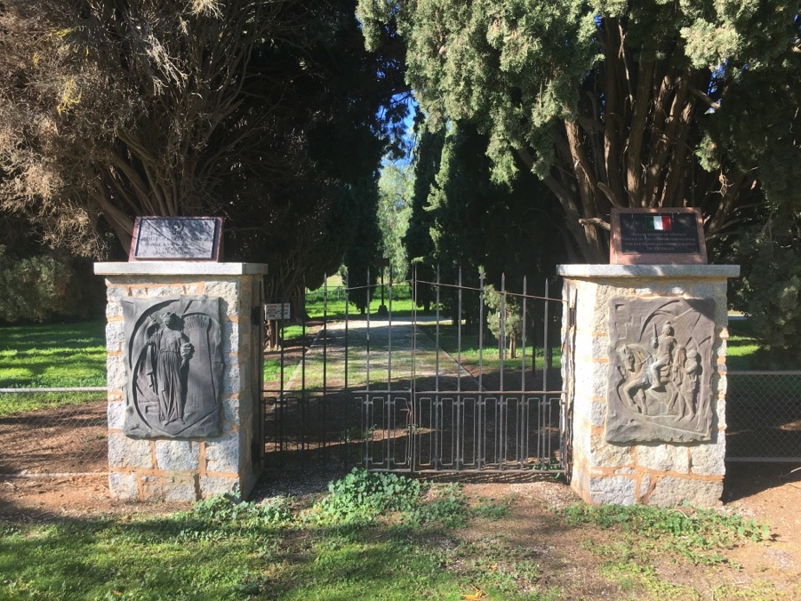
Entry gates with bas-relief sculptures, St Barbra at left and St Martin of Tours at right.

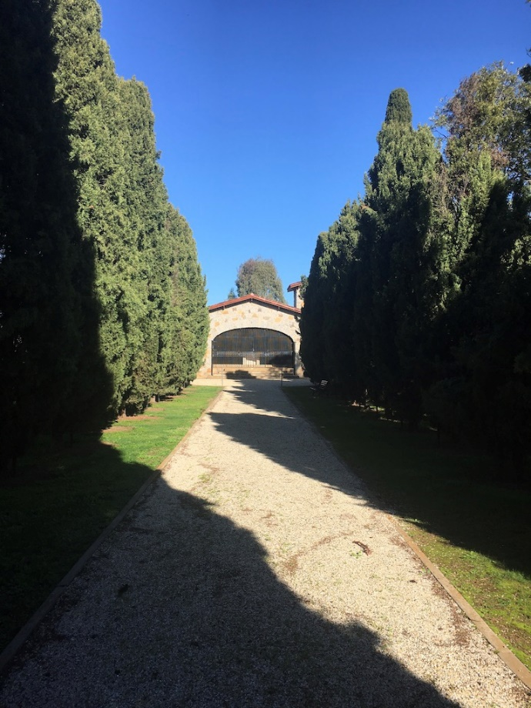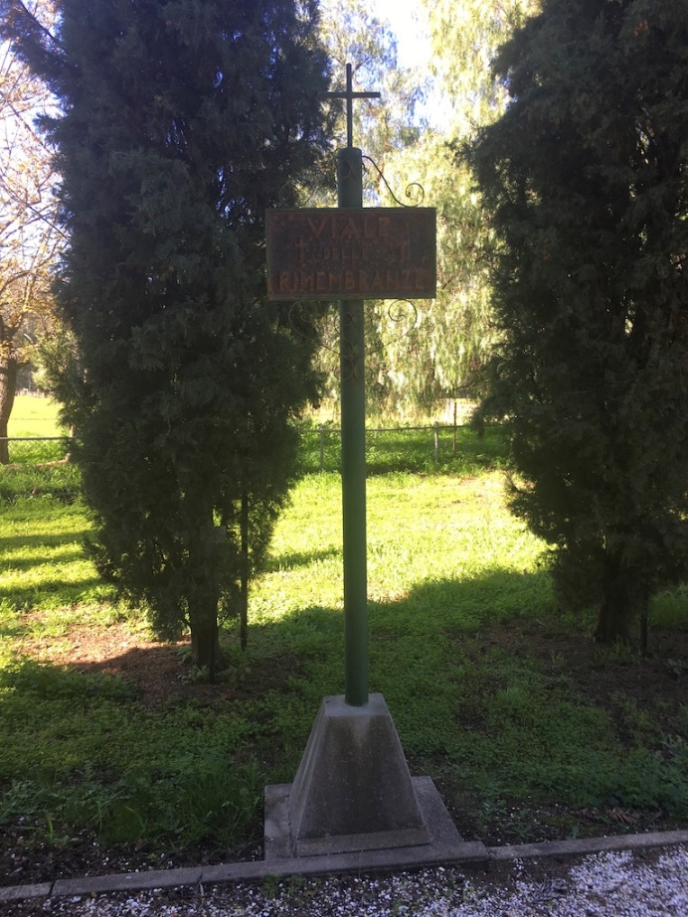
Avenue of Remembrance looking toward the Ossario, and sign at right

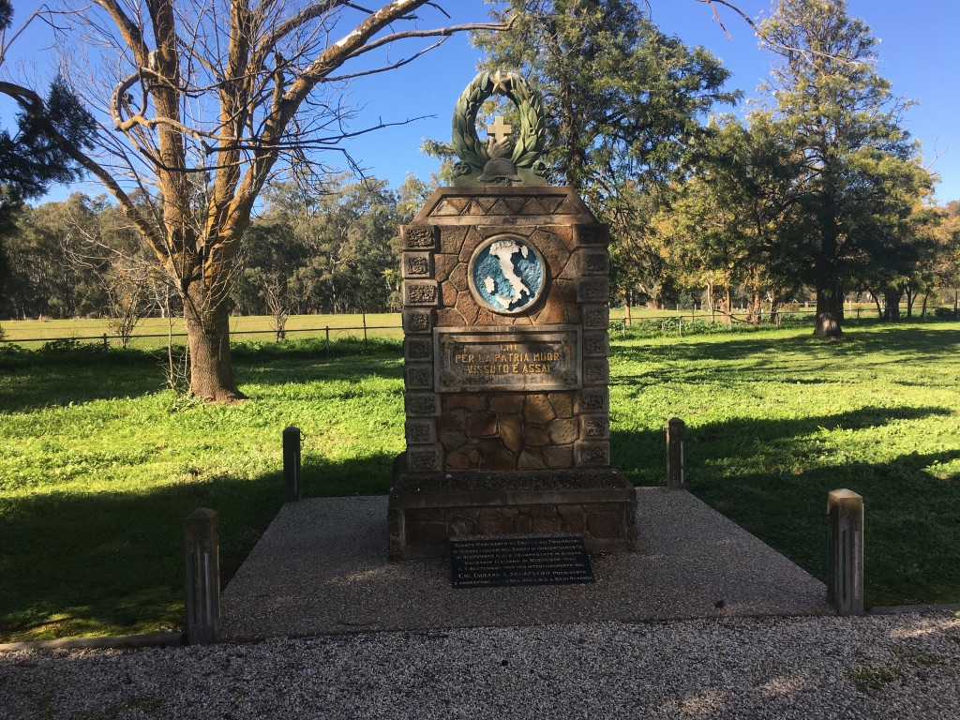
Memorial from Rushworth Internment Camp relocated here in 1968

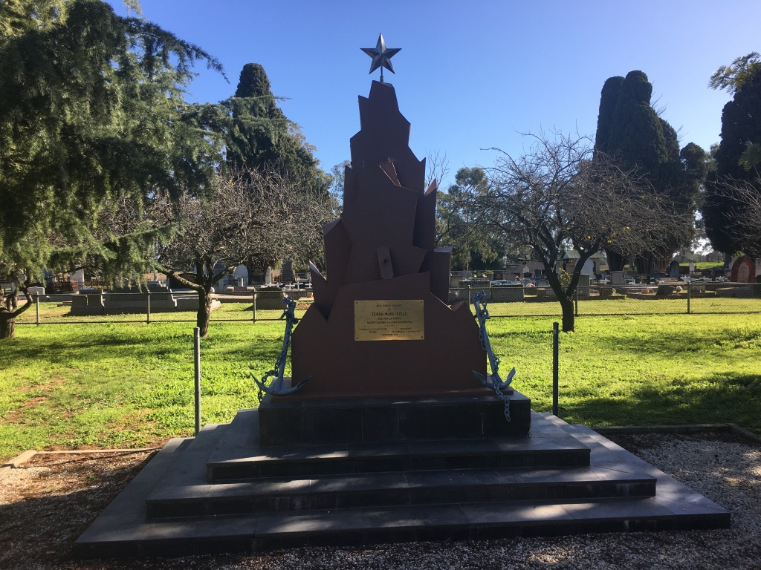
1975 memorial

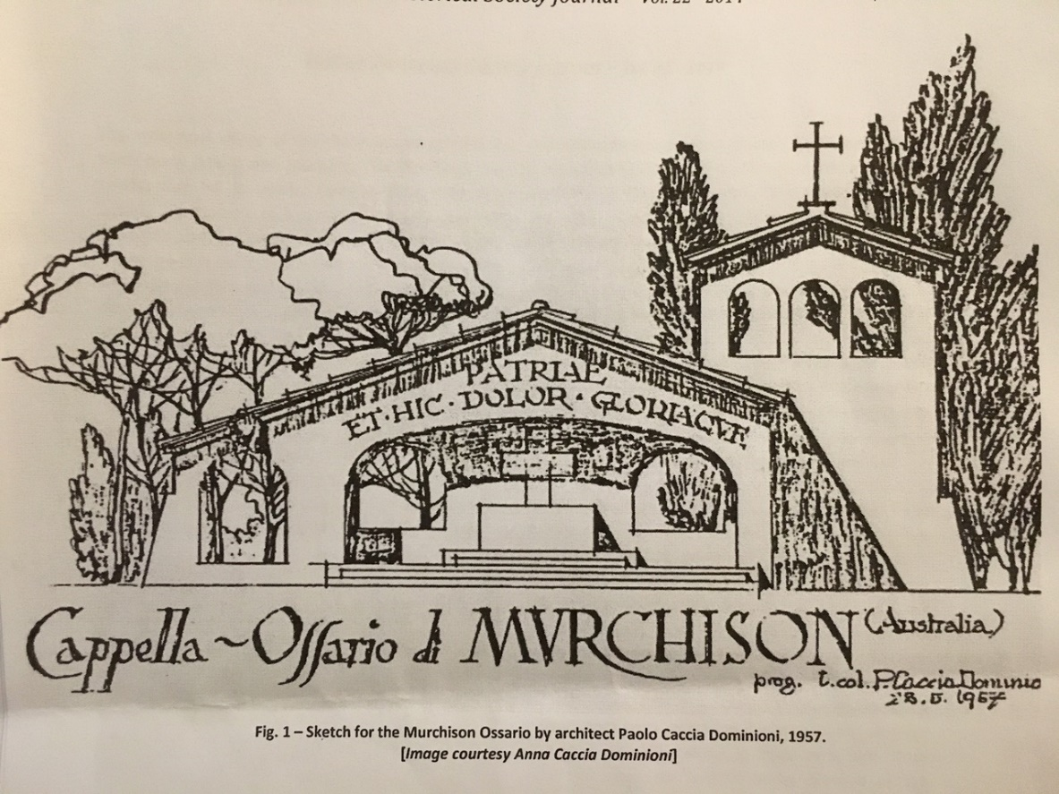
Sketch for the Murchison Ossario by Paolo Caccia Dominioni, 1957
Source: As reproduced in ‘Lest we forget: the Murchison Ossario, a sacred Italian war grave and shrine’, by Mia Spizzica

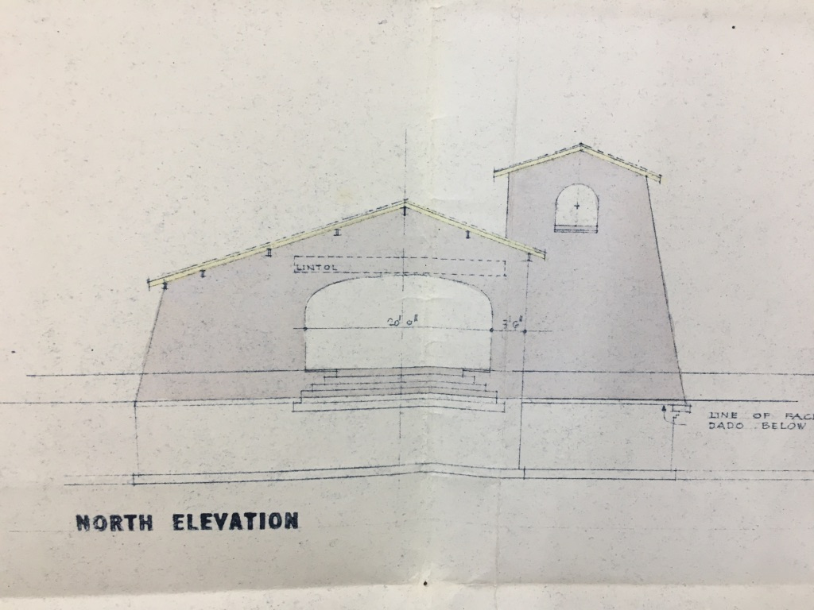
Detail of front (north) elevation, part of original building documentation
prepared by Charles N. Hollinshed Associates, Architects 26 February 1958.
Source: PROV

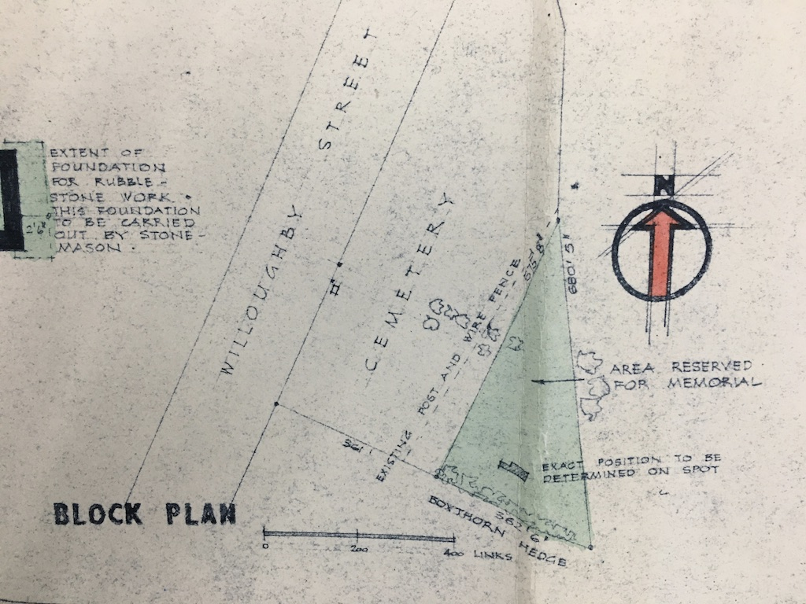
Detail of block plan, part of original building documentation
prepared by Charles N. Hollinshed Associates, Architects 26 February 1958.
Source: PROV

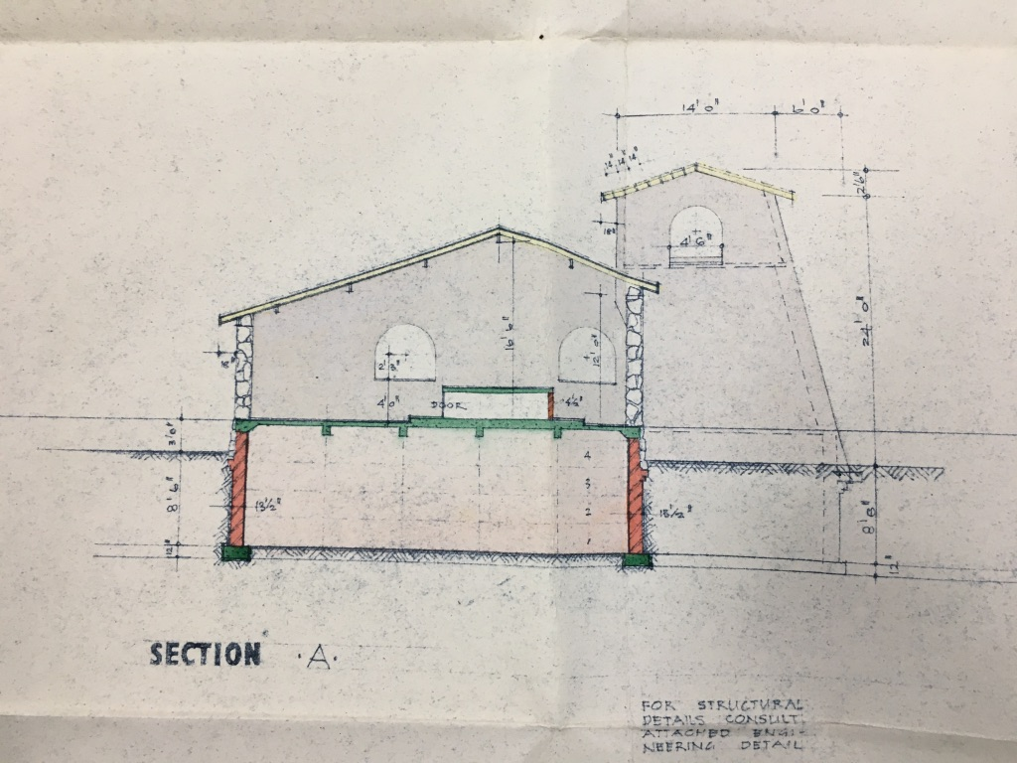
Section showing location of original crypt under chapel
prepared by Charles N. Hollinshed Associates, Architects 26 February 1958.
Source: PROV

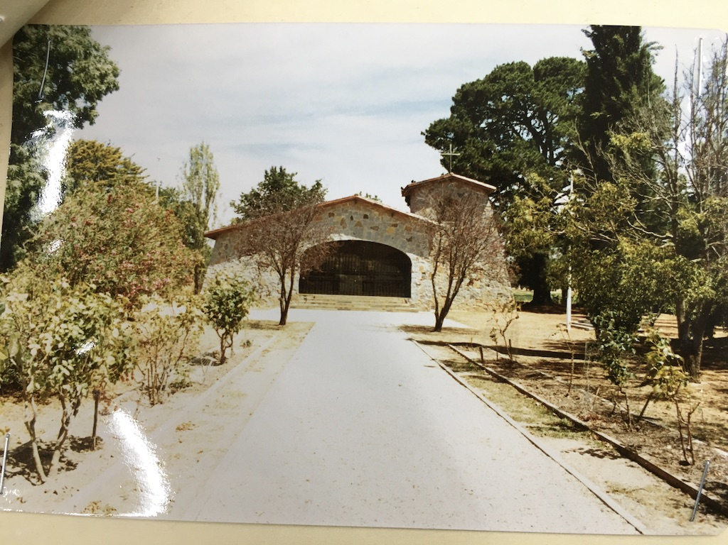
Ossario and pathway, c.1983, prior to the establishment of the Avenue of Remembrance
Source: PROV file

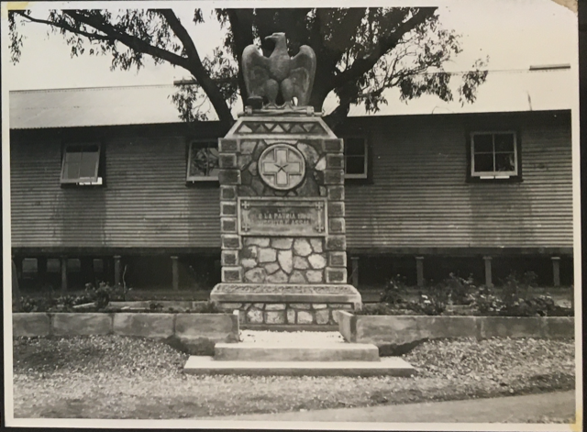
‘Murchison, Victoria, Australia, 1944-05-22 Monument built by Italian Prisoners of War
in their compound (13C) at the Murchison Prisoner of War Group’
Source: Australian War Memorial collection

CONFLICT OF INTEREST DECLARATION

You must fill this in, sign, put on file and upload to Hermes in an event step titled ‘Assessment’. Then remove this page from this report. It should not go to the Heritage Council.

NAME OF PLACE(S)/OBJECT(S):

OFFICER(S) REPORTING:

CONFLICT/INTEREST DECLARATION:
I have considered whether there is a conflict of interest in conducting a cultural heritage assessment of the above place(s) and I have determined that I have:

No Conflict

I have a conflict and have undertaken the following actions:

OFFICER’S NAME:
SIGNATURE:
DATE:
This signed form should be saved the Heritage Victoria declaration of Conflict/Interest form against the event number in HERMES. Please send to our administrator to do this.

